**SAP HANA** supports now open source tools like **GeoServer** which can be used to publish, share, process and edit geo-spatial data using open geospatial standards ([OGC](http://www.opengeospatial.org/)). OGC services such as Web Feature Service ([WFS](https://en.wikipedia.org/wiki/Web_Feature_Service)), Web Map Service ([WMS](https://en.wikipedia.org/wiki/Web_Map_Service)), Web Coverage Service ([WCS](https://en.wikipedia.org/wiki/Web_Coverage_Service)), and Web Processing Service ([WPS](https://en.wikipedia.org/wiki/Web_Processing_Service)) and others can now be consumed by connecting GeoServer to SAP HANA where all your data is located in memory (spatial, graph, business data, etc.), and can be easily embedded into your existing GIS infrastructure.

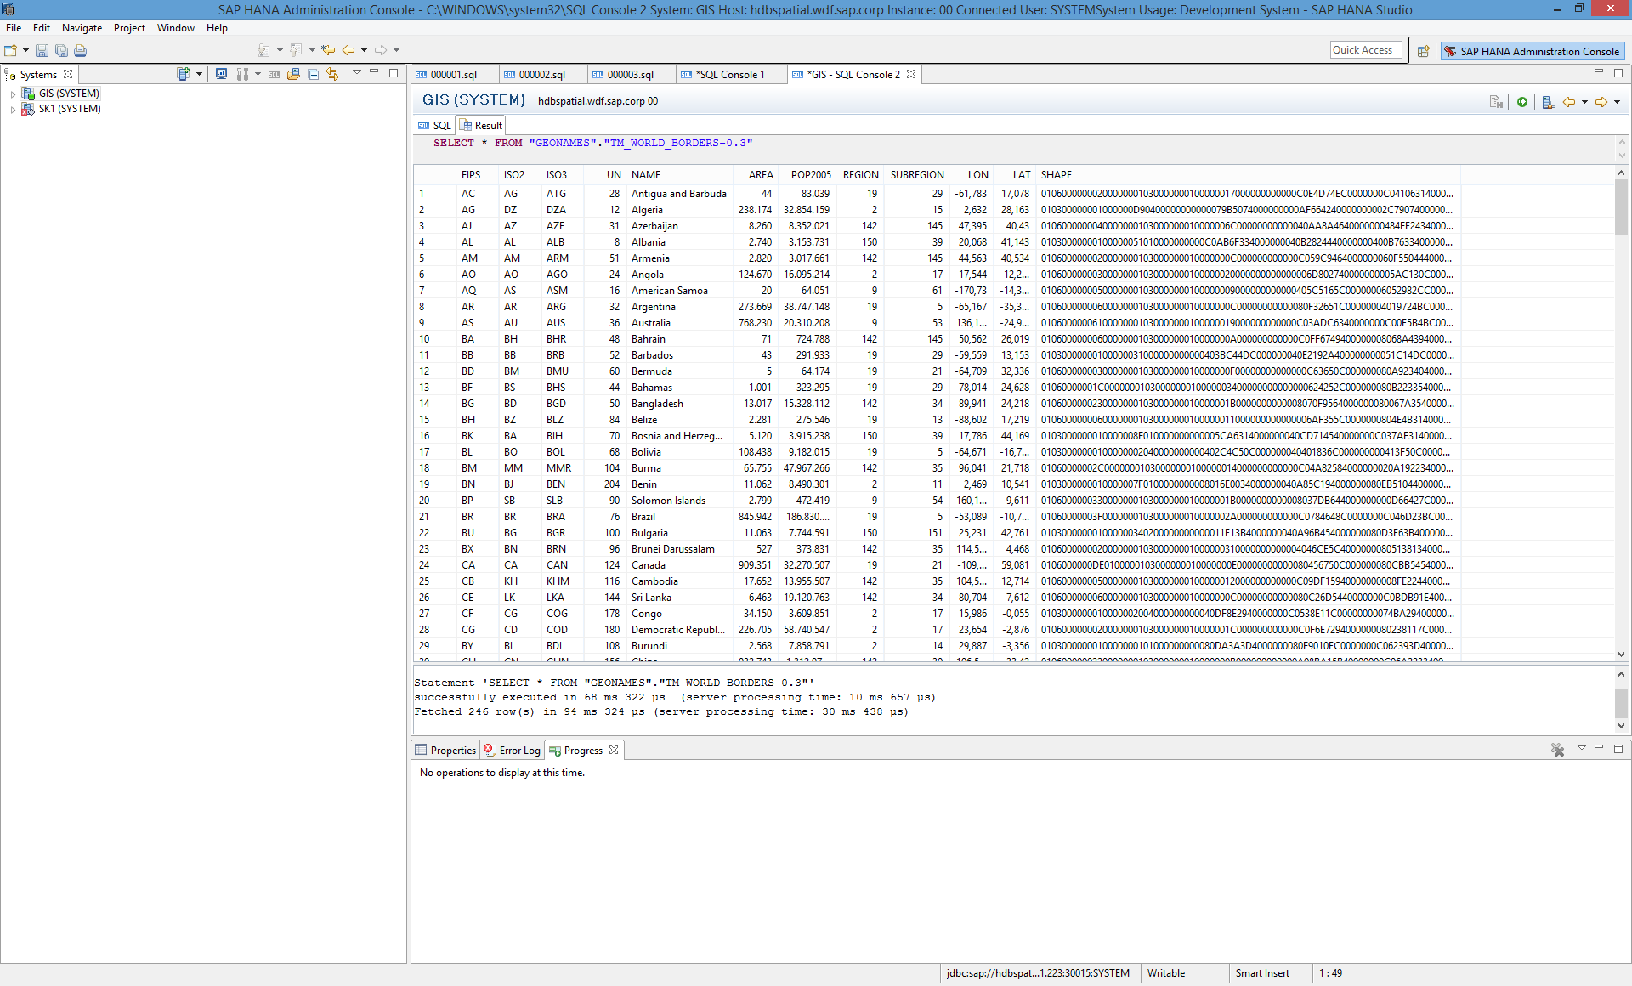Let’s get started with a simple demo. I will keep things short here. You can look into the PDF *Guide- GeoServer with SAP HANA* to get a more details on how to use GeoServer with SAP HANA. The [User Manual](http://docs.geoserver.org/stable/en/user/index.html) on the web is also a good source to get started with GeoServer. Lets download the ESRI shape-files for **World Border**[here](http://thematicmapping.org/downloads/TM_WORLD_BORDERS-0.3.zip), and import it into SAP HANA. The data would look as shown alongside.

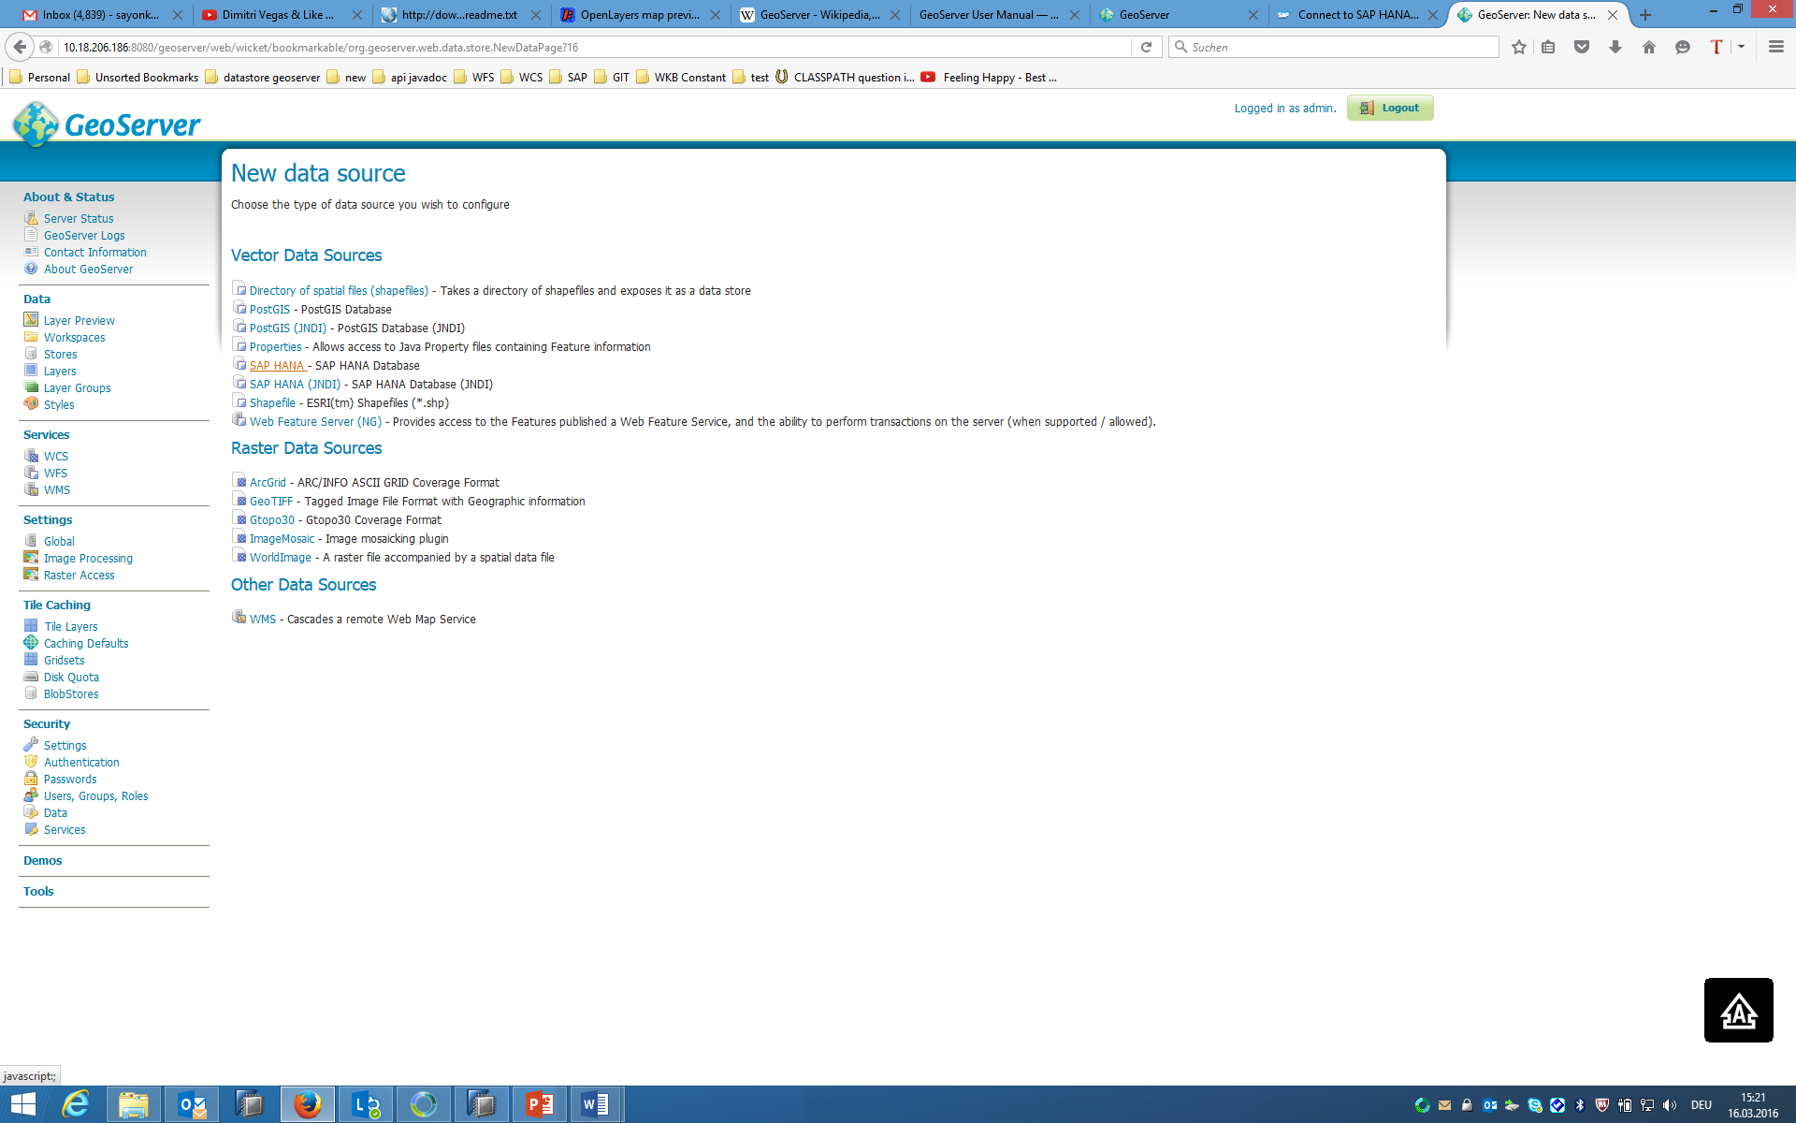Creating a **data-store** on GeoServer **workspace** for your **schema** is straight forward since you have SAP HANA right in the list of Vector Data Sources for GeoServer now. Create a data-store for your schema and **publish** the geometry table for **World Border** as a **Layer**. While publishing, either you can choose your own **Bounding Box**, or simply let SAP HANA do it for you from your data. You can have layers in several **formats** such as AtomPub, GIF, GeoRSS, GeoTiff, JPEG, KML, OpenLayers, PDF, SVG, PNG, Tiff, UTFGrid, CSV, GML, GeoJSON and Shapefile. For instance, if you click on **OpenLayers** link under Common Formats column for the layer you just published, you will have the following preview:

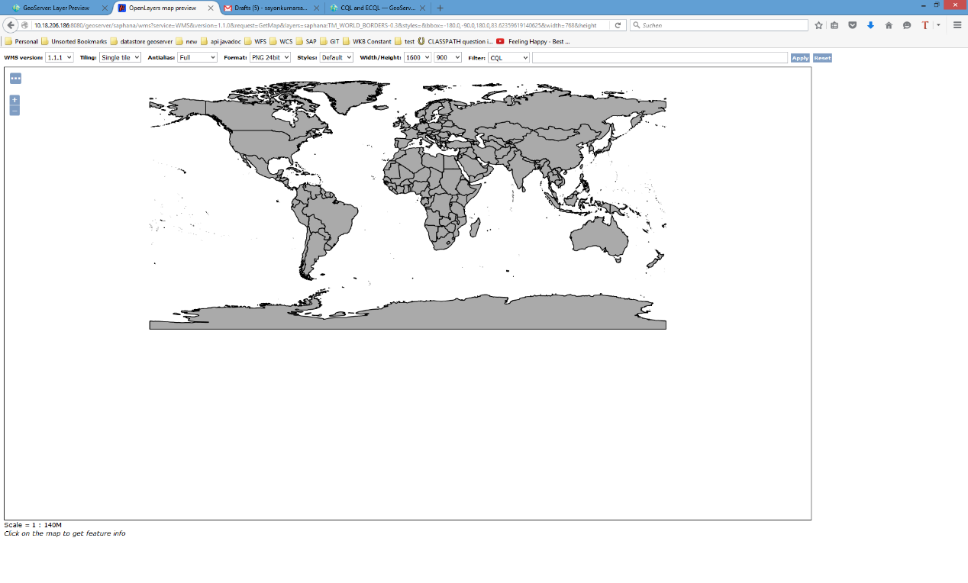

On the **CQL** (Common Query Language) bar you can type your queries for filtering. You can refer [here](http://docs.geoserver.org/latest/en/user/tutorials/cql/cql_tutorial.html) for more information on CQL. For instance, if you type the following CQL, where the Polygon represent the shape for UK, you will have the result as shown.

**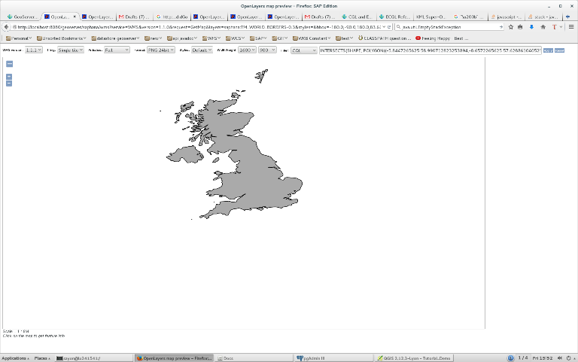***INTERSECTS (SHAPE, POLYGON ((-5.8447265625 58.990712823253894, -8.6572265625 57.62886104052531, -7.119140625 55.944201366556634, -5.5810546875 55.09840898289597, -4.833984375 54.10570980429925, -5.2734375 52.61097025175982, -6.064453125 51.503186376638034, -6.2841796875 50.255546950930764, -6.26220703125 49.761308205624985, -5.185546875 49.604925493619184, -2.28515625 50.08666612902115, 0.3955078125 50.479793575061706, 1.1865234375 50.814178573614775, 2.6806640625 51.775912838347296,2.4169921875 53.03584579937114, -0.52734375 56.578775474047085, -1.318359375 57.95676742951274, -2.021484375 58.92272697910158, -2.109375 59.64102901358082, -3.8232421875 59.50750021119756, -5.8447265625 58.990712823253894)))*

On GeoServer you can also **group** several filtered layers stacking one on top of each other, style them using existing styles, write your own **Style Layer Descriptor** or use styles from applications like UDig (explained in the PDF *Guide- GeoServer with SAP HANA*) such as the following:

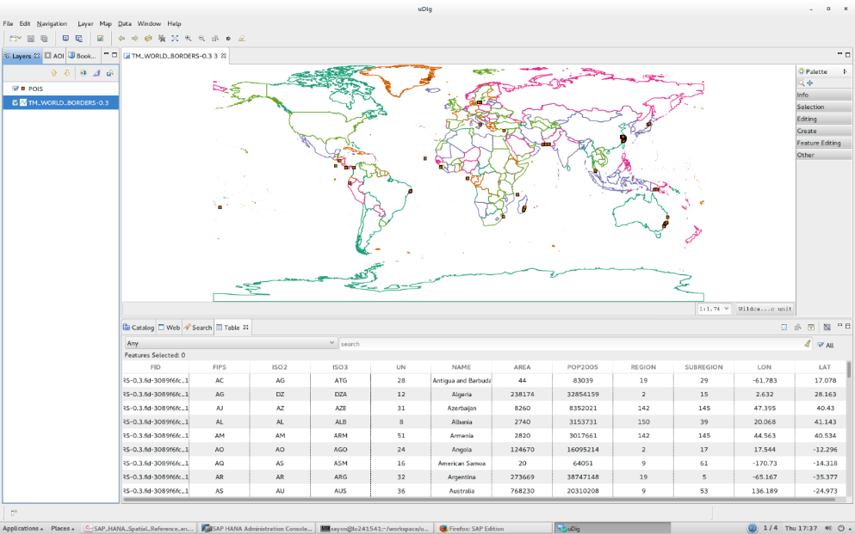

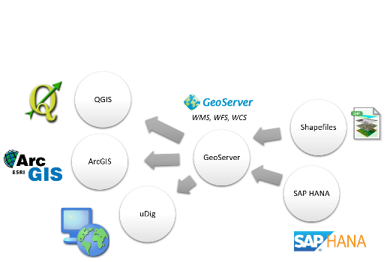

You can also create **new** **SQL Views** by writing native SQL statements for your filter, or create **new feature types** by creating spatial tables in SAP HANA from GeoServer. WFS lets your insert, update and delete data further. You can consume the OGC standaradized **WFS, WCS, and WMS** from GeoServer into your GIS applications for your data in SAP HANA.

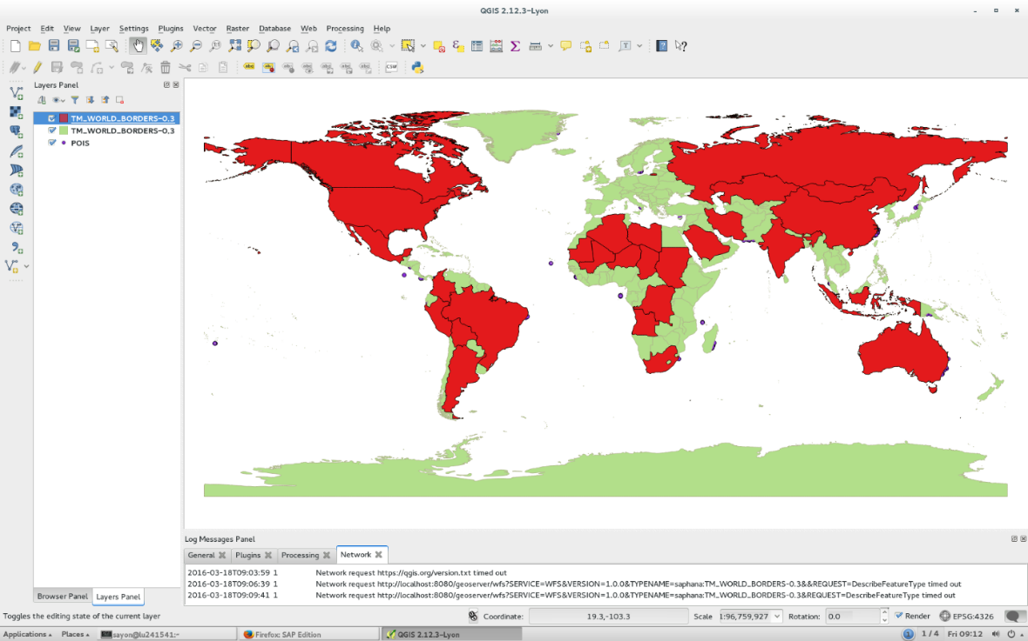For instance you can install **QGIS** and make a connection to **GeoServer** with your credentials (explained in the PDF *Guide- GeoServer with SAP HANA*). Then you can add the published layer **World Border**, from GeoServer as a **WFS Layer**. Next you can add the same layer, but click on **Build Query** before adding and type simple query like *‘AREA’>100000*. When you add both the layers, your QGIS window would look like the following:

http://www.virtustream.com/blog/wp-content/uploads/2015/07/SAP-HANA-logo.pngFile:Geotools-logo.svghttp://www.nearimprov.com/assets/geoserver.pngThe support for SAP HANA as a data-store is made not directly to GeoServer, but by integrating a module in the GIS toolkit called **GeoTools**. So applications other than GeoServer which use GeoTools such as [uDig](https://en.wikipedia.org/wiki/UDig), Geopublisher, 52N, [Geomajas](https://en.wikipedia.org/wiki/Geomajas) and other proprietary projects will also have SAP HANA as one of recognizable data-store.

That’s all for now. Go ahead and use the GeoServer features for your GIS applications with your spatial data in SAP HANA.